B0829060黃至祥

由於許多編譯器需要特別設定或是編譯的標頭檔並不滿足需求，故使用visual stdio作為編譯的工具

注意!要進入偵錯->server偵錯->c/c++一般 將SDL檢查設定為否

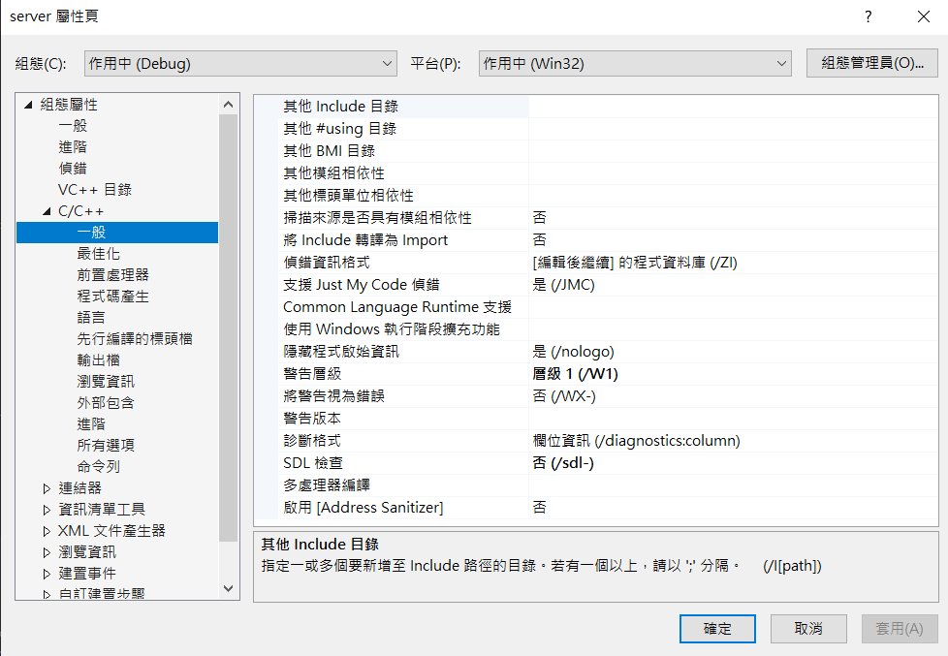

程式碼

#define WIN32_LEAN_AND_MEAN

#include <windows.h>

#include <winsock2.h>

#include <ws2tcpip.h>

#include <stdlib.h>

#include <stdio.h>

// Need to link with Ws2_32.lib, Mswsock.lib, and Advapi32.lib

#pragma comment (lib, "Ws2_32.lib")

#pragma comment (lib, "Mswsock.lib")

#pragma comment (lib, "AdvApi32.lib")

int merror(int redata, int error,char* showinfo) {

if (redata == error) {

perror(showinfo);

getchar();

return -1;

}

return 0;

}

void sendhtml(SOCKET s, char* filename);

int main() {

printf("歡迎使用webser\n");

WSADATA wsdata;

int isok=WSAStartup(MAKEWORD(2,2),&wsdata);//確定socket版本

//short 2 character 2.2

char* str1 = (char*)"申請socket失敗";

merror(isok, WSAEINVAL, str1);

//第一個:協議族，決定socket地址類型

//第二個:傳輸類型,SOC_STREAM傳輸

//第三個:指定傳輸協議,tcp

SOCKET server = socket(AF_INET, SOCK_STREAM, IPPROTO_TCP);

char* str2 = (char*)"創建socket失敗";

merror(server, INVALID_SOCKET, str2);

struct sockaddr_in seraddr;

seraddr.sin_family = AF_INET;

seraddr.sin_port = htons(80);

seraddr.sin_addr.s_addr = INADDR_ANY;//監聽任意地址

isok=bind(server, (sockaddr*)&seraddr, sizeof(seraddr));

char* str3 = (char*)"綁定失敗...\n";

merror(isok, SOCKET_ERROR, str3);

isok = listen(server, 5);

char* str4 = (char*)"監聽失敗...\n";

merror(isok, SOCKET_ERROR, str4);

struct sockaddr_in claddr;

int cllen = sizeof(claddr);

while (1) {

SOCKET client = accept(server, (sockaddr*)&claddr, &cllen);

char* str5 = (char*)"連接失敗...\n";

merror(client, INVALID_SOCKET, str5);

char revdata[1024] = "";

recv(client, revdata, 1024, 0);

printf("%s 共接收到%d字節數據\n",revdata,strlen(revdata));

char sendata[1024] = "<h1 style=\ color:red;\">你好，我成功了!</h1>";

//send(client, sendata, strlen(sendata), 0);

char *filename = (char*)"./index.html";

sendhtml(client, filename);

closesocket(client);

}

closesocket(server);

WSACleanup();

getchar();

return 0;

}

void sendhtml(SOCKET s, char* filename) {

FILE *pfile = fopen(filename,"r");

if (pfile == NULL) {

printf("開啟文件失敗\n");

return;

}

char temp[1024] = "new";

do {

fgets(temp, 1024, pfile);

send(s, temp, strlen(temp), 0);

} while (!feof(pfile));

}}編譯結果

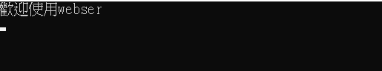

到local host127.0.0.1可以看到網頁

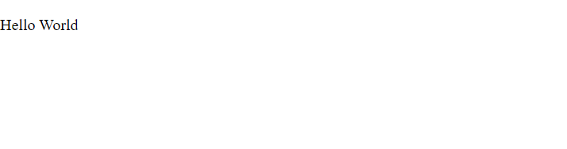

視窗改變

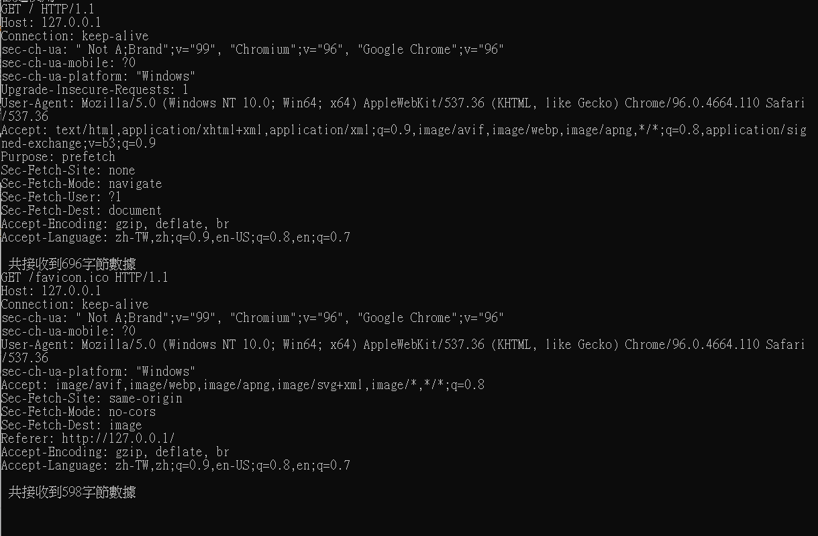

chrome顯示status200

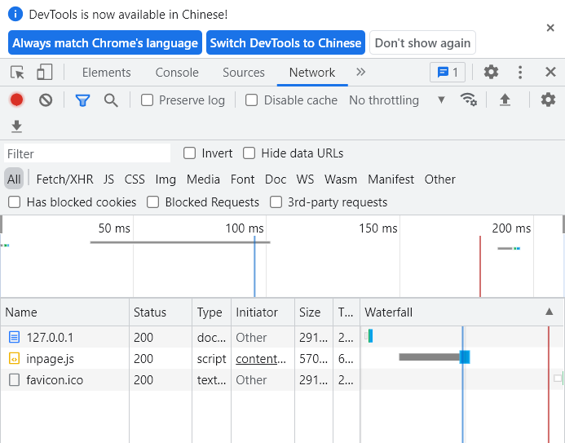

參考資料:

**C/C++知识分享：用c实现的极简的web server，搭建超简单的web服务器！**  
<https://www.bilibili.com/s/video/BV1464y1f7uT>

遇到的問題:

我在將其改為cpp檔的過程中，遇到了回傳錯誤字串需要使用*char，但string被視為constant char的情況，透過強制轉換型態就解決了。

另外遇到了sockaddr_in與sin_family的設定產生變化

原本:

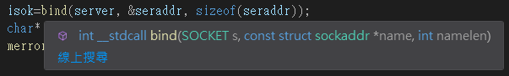

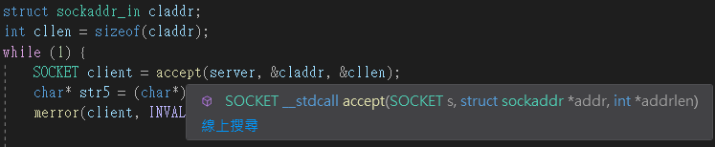

後來:

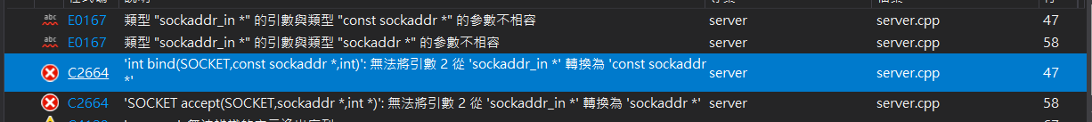

在c/c++中，sockaddr與sockaddr_in屬於同構的struct，可透過強轉換達成需求

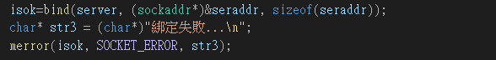

內部結構:

typedef struct sockaddr_in {

#if(_WIN32_WINNT < 0x0600)

short sin_family;

#else //(_WIN32_WINNT < 0x0600)

ADDRESS_FAMILY sin_family;

#endif //(_WIN32_WINNT < 0x0600)

USHORT sin_port;

IN_ADDR sin_addr;

CHAR sin_zero[8];

} SOCKADDR_IN, *PSOCKADDR_IN;

typedef struct sockaddr {

#if (_WIN32_WINNT < 0x0600)

u_short sa_family;

#else

ADDRESS_FAMILY sa_family; // Address family.

#endif //(_WIN32_WINNT < 0x0600)

CHAR sa_data[14]; // Up to 14 bytes of direct address.

} SOCKADDR, *PSOCKADDR, FAR *LPSOCKADDR;